BUSINESS QUESTIONS FOR THE POWER BI DASHBOARD
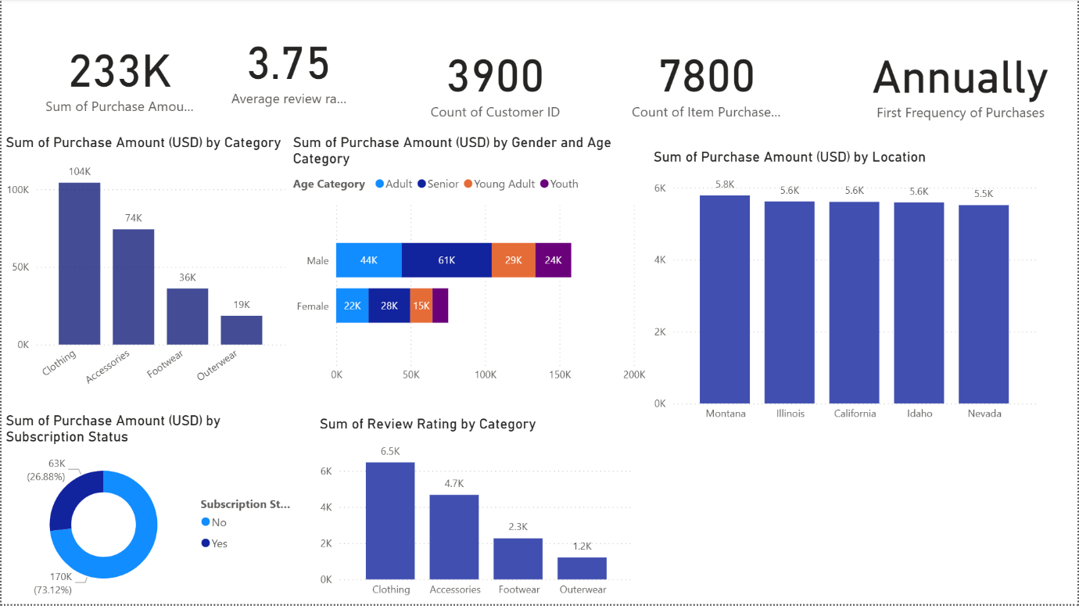

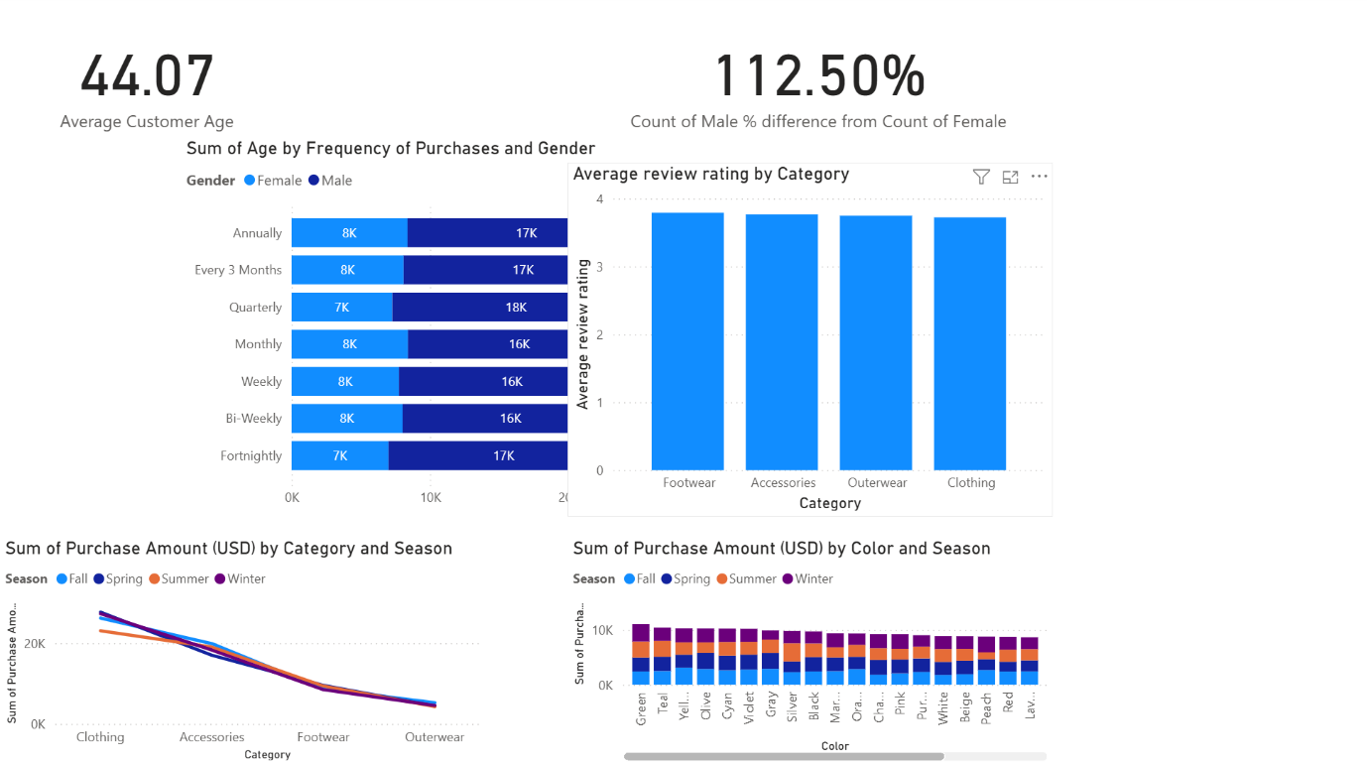

1. Average Customer Age
Business Question:
What is the average age of our customers, and what does that mean for how we market to them?

2. Gender Distribution (% Difference)
Business Question:
Is our customer base dominated by one gender, and how should that influence product design or marketing focus?

3. Sum of Age by Frequency of Purchases and Gender
Business Question:
Which gender and age groups shop more frequently, and who are our most loyal customer segments?

4. Average Review Rating by Category
Business Question:
Which product categories are customers happiest or least satisfied with?
(Useful for product improvements or supplier decisions.)

5. Sum of Purchase Amount by Category and Season
Business Question:
How does seasonal demand vary across product categories?
(Helps in planning seasonal promotions and inventory.)

6. Sum of Purchase Amount by Color and Season
Business Question:
Which colors sell best during specific seasons?
(Helps in design, merchandising and fashion planning.)

7. Total Purchase Amount by Category
Business Question:
Which product categories generate the highest revenue, and where should we invest more?

8. Total Customers / Count of Customer ID
Business Question:
How large is our customer base and how fast is it growing?

9. Count of Items Purchased
Business Question:
How many total items are we selling, and which factors drive higher purchase volume?

10. First Frequency of Purchases
Business Question:
How often do our customers tend to shop?
(Shows buying behavior patterns.)

11. Purchase Amount by Gender and Age Category
Business Question:
Which age-gender combinations contribute the most to total revenue?
(Supports targeted marketing.)

12. Purchase Amount by Location
Business Question:
Which geographic areas generate the most revenue?
(Helps with location-based marketing or expansion.)

13. Purchase Amount by Subscription Status
Business Question:
Do subscribers spend more than non-subscribers?
(Shows the value of the loyalty/subscription program.)

14. Total Review Rating by Category
Business Question:
Which categories receive the most customer feedback and how positive is it?
(Useful for identifying problem categories.)

